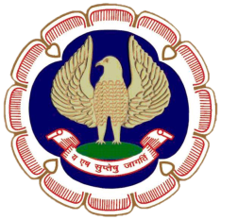

SICASA
ERNAKULAM BRANCH OF SICASA OF
THE INSTITUTE OF CHARTERED ACCOUNTANTS OF INDIA

“ICAI Bhawan”, Diwan’s Road, Kochi – 682016. Ph : 0484 – 2369238
Email : ernakulam@icai.org Website : www.kochiicai.org

Cordially invite you to the

ONE DAY SEMINAR

ON

TAX AUDIT

on Tuesday, 8th August 2017

at YMCA Hall, Chittoor Road,

Behind Shenoys Theatre, ERNAKULAM

Time : 09.00 a.m. to 5.00 p.m.

CA. ROY VARGHESE FARZEEN FAZAL
Chairman, SICASA, EKM Br Secretary, SICASA , EKM Br

Registration Fee : Rs. 200/- for CA Students & Rs. 400/- for Others

MEMBERS ARE ALSO WELCOME

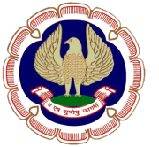

ERNAKULAM BRANCH OF SICASA OF
THE INSTITUTE OF CHARTERED ACCOUNTANTS OF INDIA

ONE DAY SEMINAR ON TAX AUDIT

PROGRAMME

09.00 am Registration

09.30 am Inauguration & Honouring IPCC Winners from Ernakulam Branch of ICAI

10.00 am First Technical Session

Tax Audit –
A Practical Approach to Audit under Section 44 AB

Speaker: CA. BALACHANDRA PRABHU S. B

11.30 am Second Technical Session

Analysis of Loans & Deposits, Cash Transactions and TDS
Provisions with reference to Tax Audit

Speaker : CA. P.T. JOY

01.00 pm LUNCH

02.00 pm Third Technical Session

Analysis of Form 3 CD & reporting requirements
with reference to ICDS

Speaker : CA. VIVEK SATHYAN

04.30 pm Interaction

04.55 pm Vote of thanks

